Trapping Guidelines
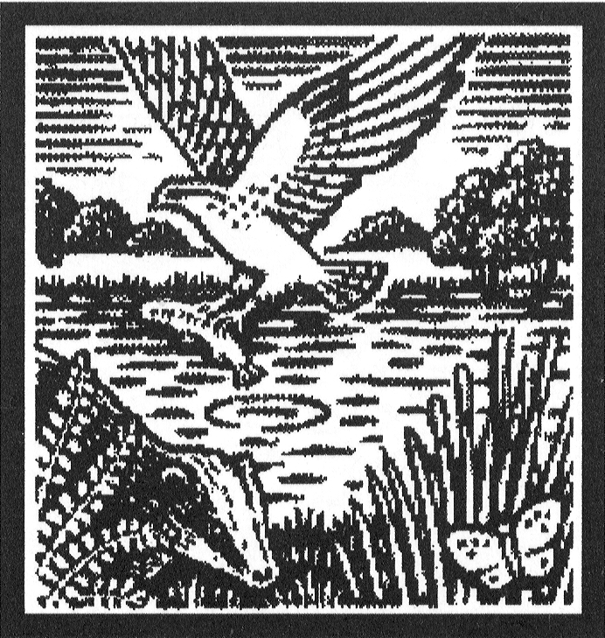

MINK CONTROL BACKGROUND

Any mink control campaign must be properly researched, carried out and monitored by people with relevant experience and competence. It must have a stated objective, be for a defined period and should be reviewed, altered or terminated at specified intervals in the light of monitoring results. Where the need for mink control is felt to be ongoing, it must be properly justified through this process. Trapping is considered to be part of an overall strategy to help water voles and other wildlife locally. Positive habitat management can also be undertaken or encouraged to increase the amount and variety of suitable habitat available. Simple measures can help, such as fencing a section of riverbank to prevent excessive poaching by cattle or thinning bank-side shade.

The efforts of a network of volunteers is the key to the success of most campaigns. Whilst a concerted effort is sometimes required to control high numbers of mink, any effort is of value to the campaign. Volunteer monitors and trappers are encouraged to put in the amount of effort they feel able to without the task becoming onerous. For some gamekeepers or water bailiffs who patrol a daily beat, it may be possible to trap or monitor continuously. However, for most people this is not possible. Most are able to perform a 5 minute check of a mink raft every 2 to 4 weeks for most of the year and a daily check of a trap, for at most a week at a time, when a mink is detected. Some may be able to do so for only a few months of the year.

Water voles undergo a high winter mortality (up to 70%) and the mink’s early breeding ensures that, to feed her kits, the female mink will take winter-surviving water voles before they have had a chance to breed. So, the best time to trap mink is usually prior to or around their breeding season in early spring (Feb-Apr). Trapping in August-November is also recommended to intercept dispersing juveniles. Mink will take water voles at other times of the year but trapping during these two periods is likely to be the most effective use of time and resources.

An average mink territory size along a linear waterway may be up to 5km for a male and 1km to 3km for a female, so trapping in only one locality may create a local territory vacuum which will be quickly filled by neighbouring mink. Only trapping over a wider area (whole stream or river catchment) is likely to have a long-term benefit for the water vole and other wildlife. The co-operation and involvement of neighbouring landowners and managers is a key factor in the effectiveness of the mink control programme.

Mink are able to but do not usually travel very far from a linear watercourse, so it is worth concentrating trapping effort along these. They generally hunt along water margins, so traps should be placed as close to the watercourse or water body as possible. Good sites are at the junctions of streams and ditches; where a watercourse flows close to a lake; and near fallen trees. Obvious man made features can be utilised, such as landing stages, angling platforms, bridges, sluices, and so on. Mink often follow linear features such as fences. Other good sites are near sources of prey, such as moorhen nests, rabbit warrens, rearing pens, water bird roosts etc.
TRAPPING & DISPATCH GUIDANCE NOTES

The following guidelines should be followed:

- Any trapping of mink must be done humanely

- Trapping should be undertaken in compliance with Health & Safety procedures for working near water, and fingers should be kept of reach of trapped animals.

- Only live capture cage traps are supplied, so that non-target species can be released unharmed. Break-back traps may be used by trained professionals.

- Otter exclusion guards must be fitted to prevent the accidental trapping of otters.

- Traps must be set away from known otter holt sites.
Traps must be set away from open areas and public paths.
Traps must be placed above any possible rise in water level and secured to prevent any trapped animal rolling them over into the water.

- Traps should be covered in hay, reed, sedge etc, which a trapped animal can pull into the cage as bedding material to reduce the stress of capture. This can then be covered with wooden boards, sticks, branches or other material to disguise the trap. This will make it more likely that a mink will investigate it as a tunnel and will prevent bedding from blowing away or being eaten by livestock.

- Traps may be baited or not. Different mink respond to different baits but usually avoid stale bait. Baits include fish (tinned or fresh), rabbit pieces, dead chicks, dry cat food, etc. Many successful trappers do not bait; some use scents such as fresh ferret droppings or fish oil. The best bait, but hardest to obtain, is the scent of another mink with fresh meat and blood. It is usually best to wear gloves when handling traps to avoid transferring human scent.

- Traps must be checked at least once per day, preferably twice per day around dawn and dusk to prevent stress to (or death of) non-target animals. It is a legal requirement that traps are checked at least once per day.

- To dispatch mink humanely, the only presently accepted methods are shooting and veterinary euthanasia. They must not be drowned (this is illegal and cruel).

- Once positively identified, mink must be shot whilst in the trap. The best method is a shot to the head with a powerful .22 or .177 air rifle. A shotgun may be used but only from a safe distance (10m+) and using eye protection against ricochet. The use rim-fire rifles is not recommended due to the risk of injury from ricochet.

- Animals which must be dispatched are: mink, grey squirrel, rat, polecat-ferret. Other animals should be released, especially: water vole, polecat. However, polecats and polecat-ferret appear very similar, if unsure, do not dispatch.

- Once caught, it is illegal to release mink back into the wild.

